Using whisper to control video streaming on the videocoin network

**Process description**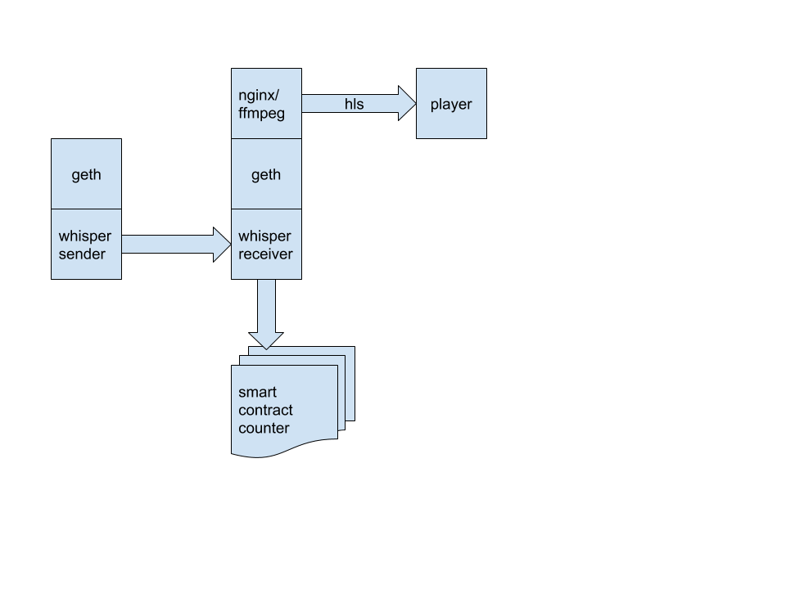

1. two nodes use geth with shh-api (whisper) on a vcnet2 network
2. whisper sender sends messages to the vcnet2 network
3. whisper receiver receives messages and turns them into system commands
4. currently implemented a scheme with symmetric keys
5. the start message starts streaming to ffmpeg / nginx and sends the transaction to the ethereum counter contract, increasing the counter by 1
6. the stop message stops streaming to ffmpeg / nginx and sends the transaction to the ethereum counter contract, decreasing the counter by 1

The player can be found here.

<http://35.204.176.123/player.html>

the state of the stream and counter changes every 3 minutes